**صورة تحتوي على نص, رسم بياني, رسم, شكل

تم إنشاء الوصف تلقائياًUsecase Diagram:**

**Activity Diagram:**

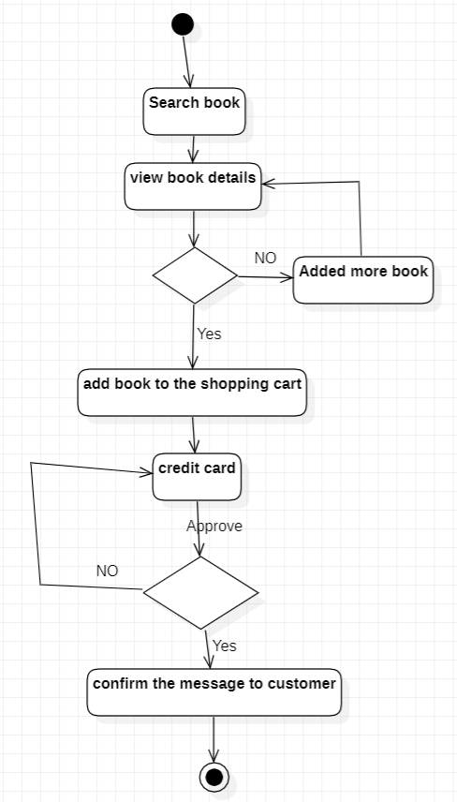

**Usecase Specification:**

|  |  |  |
| --- | --- | --- |
| Use case name | Purches book | |
| Actors | User, Bank | |
| Summary | This use case enables the customer to Search for books, View book details, add a book, Purchase a book with credit card, Cancel purchase, View order history and report generation. | |
| Basic flow of the event | Actor action:   1. The user visits the bookshop website and decides to register as a user. 2. The user fills in the registration form and submits it. 3. The user selects a book they are interested in viewing also the details of a book they are interested in purchasing. 4. When the user ready to purchase a book, the customer can select the payment option 5. The user can choose to view their order history or continue shopping. 6. The bookshop owner maintains an inventory of available books for sale 9.The owner can adds new books to the inventory, updates existing books, or deletes books as needed. | System response:  2.1The user is able to browse  3.1the available books on the website  The user reads the book details and decides to add the book to their cart  4.1The user enters their billing information and payment method. If the payment is successful, the bookshop receives the payment and sends a confirmation to the user. |
| Alternate Flow | - If The user want to cancel the purchase by logging in to their account and making the request.  -error message from the bank | |
| Pre-conditions | - User has selected a book version and added to their cart - User has a valid credit card | |
| Postconditions | If the payment is authorized, the user's credit card is charged and the book is reserved for the user.  If the payment is declined, the book remains available for purchase and the user is prompted to try again with a different payment method. | |